**Cameron Gayford  
[camgayford@gmail.com]**

CIS219.01 - Introduction to Java

Spring 2014

Program # **3 Summary Report**

Date turned in: Thursday April 10, 2014

Due Date: Thursday April 10, 2014   
Completed for Professor Habermas, office D273

Collect transaction data [product type, quantity, shipping] from User input,  
 process, then generate detail and summary reports.

Sample Output – Gui:

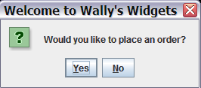 Select [Yes.] User may choose to exit the program by selecting [No]

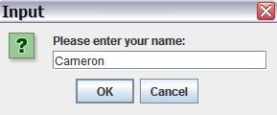 Enter a string. This is not validated.

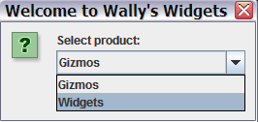 Select “Widgets”. User cannot select an invalid input.

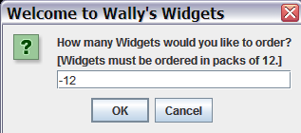 Invalid – not a positive integer. [See console output]

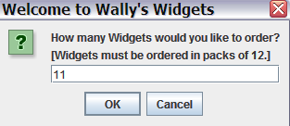 Invalid – not a multiple of 12. [See console output]

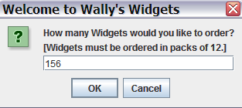 Invalid – greater than upper bound. SPECIAL CASE. [See next]

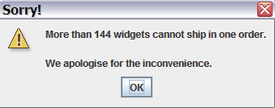Special error message is also output in console.

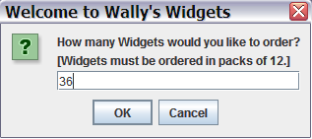 Valid input – program proceeds.

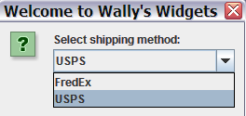 Select “USPS”. User cannot select an invalid input.

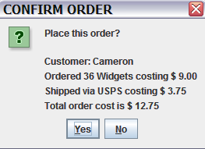 Detail report is prepared; User must confirm before report commits.

Select [Yes]. Order counter increments, program proceeds.

User may select [No] to cancel this order and proceed without adjusting these variables.

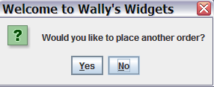 Select [No} to finalize the orders. User may select [Yes] to repeat the loop and commit arbitrarily more orders.

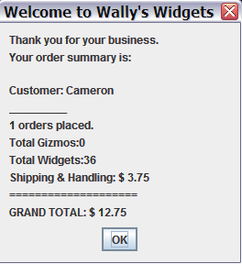 Summary report prepared, displayed, and output to console.

Sample Output – Console:

